BECOMING HUMAN, PART I: “FIRST STEPS”
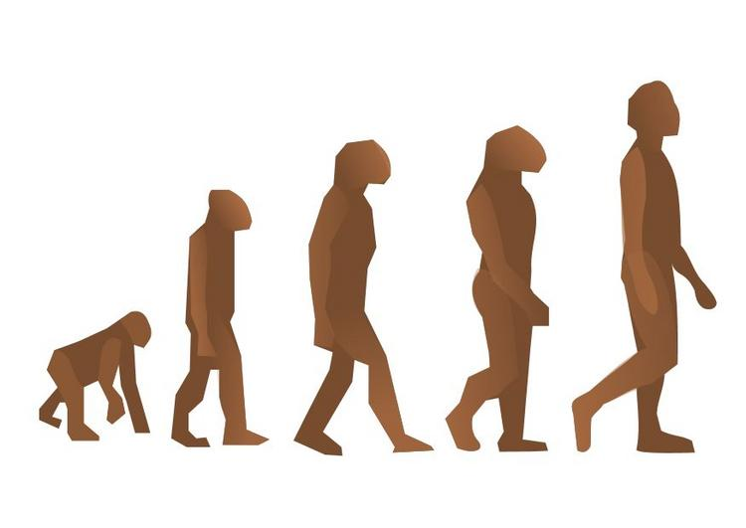

As you watch the documentary, answer the following questions.

1. What is the significance of the discovery of a fossil named “Salaam” (or “peace” in Ethiopian)?

2. a) Roughly when was Salaam living?

b) How do we know this?

3. What was the climate/environment of Africa like approximately six million years ago?

4. According to bio-mechanist Daniel Lieberman, why did human ancestors become bipedal (walked upright)?

5. What is the Molecular Clock and how does it work?

6. What was the significance of the discovery of Sahlenthropus Tchadensis?

7. What evidence is used to suggest that brain development was happening in early human ancestors?

8. What was the climate of Africa like approximately three million years ago to one and a half million years ago?

9. How are these latest discoveries being used to challenge traditional conceptions of human evolution?

BECOMING HUMAN, PART II: “BIRTH OF HUMANITY”

As you watch the documentary, answer the following questions.

1. a) What species appeared about two million years ago?
b) What were the significant changes from earlier species?

2. What kinds of “big questions” can be answered with a nearly complete ancient skeleton?

3. What is a “brain endocast” and what can be learned from them?

4. In what ways are stone tools indicative of an increase in the “thinking power” of Homo erectus?

5. a) What are the hidden costs of large brains?

b) What did larger brains mean for early humans in terms of food supply?

6. a) What is “persistence hunting”?

b) How does the loss of body hair relate to persistence hunting?

7. How can the deeper social aspects of modern humans be explained through evolutionary
developments?

8. a) When did Homo erectus leave Africa?
b) Why?

9. What is the significance of Homo floresiensis (or The Hobbit)?

Intro to Anthropology Morrisville State College ANTH 101 Prof. Reymers
http://www.pbs.org/wgbh/nova/evolution/becoming-human-part-3.html Becoming Human worksheet Part III: “Last Human Standing”
1. In what order of descent did the species of Homo overtake one another and when?

2. What was discovered in the caves at Atapuerca, in northern Spain and what does this say about archaic Homo sapiens (Homo heidelbergensis in this case)?

3. What is “Excalibur” and what did it signify?

4. In what ways did our ideas about Homo neandertalensis change as the 20th century proceeds?

5. What recent discovery in the Meuse Valley, Belgium, helped to refine our views of Neanderthals?

6. What kind of research is going at the Max Planck Institute in Leipzig, Germany, regarding evolutionary studies?

7. Why are children’s teeth so valuable to archaeologists?

8. Why was hunting such a risky business for Neanderthals?

9. Why did Neanderthals go extinct about 25,000 years ago?

10. What is “the bottleneck effect”?

